**Magento Promotions:**

* Magento Promotions is mainly used for increasing customer awareness about your Magento 2 site.
* promotions can help boost the conversion rate of your online store

**Types of Magento Promotions:**

* Catalog price rule
* Cart price rule

**Catalog Price Rule:**

* Catalog price rule is let you lower the product cost
* It works for all items on your Magento website
* Once you set a rule, it adjusts product prices according to the special promotion.
* **To set new catalog price rules**

1. Navigate to the **Admin Panel**.
2. Expand the **Marketing** section, and find the **catalog price rule** tab.
3. Add a New Rule.
4. Set rule **conditions** for the new catalog price rule.
5. Define the **Actions**.
6. **Save** and **test** the new rule.

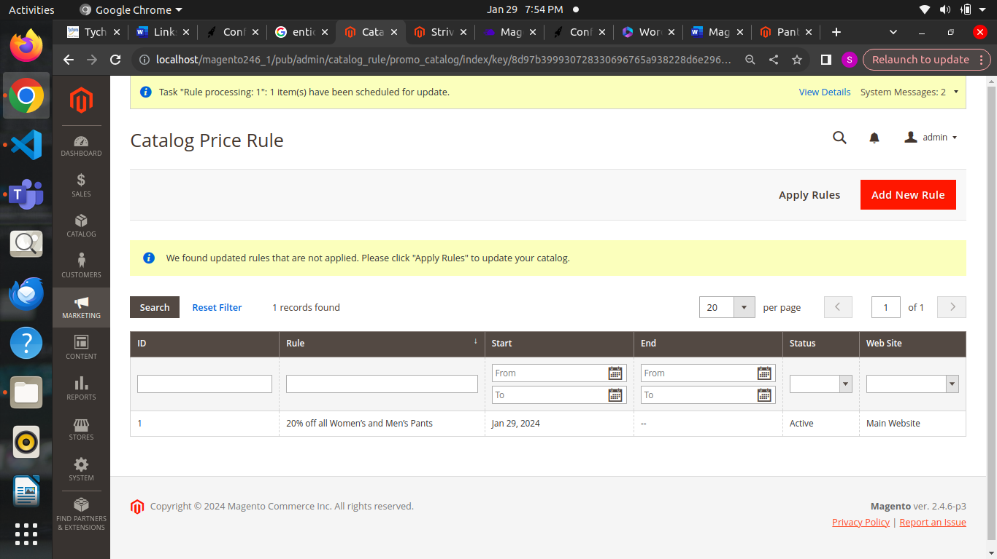

**Set the conditions:**

* Under the Catalog Price Rule, choose Condition tab.
* The short message **If All of these conditions are TRUE** is visible for you, and especially, you can customize the message when click on **ALL** and **TRUE** link.

Click on the **ALL** link, ALL and ANY options are available.

Click on the **TRUE** link, TRUE and FALSE options are available.

* Leave the conditions blank if you want to apply for all products
* Click on Add icon to set conditions for the rule:

Set the Product Attribute as the basic of the conditions such as Attribute Set, Category, etc.

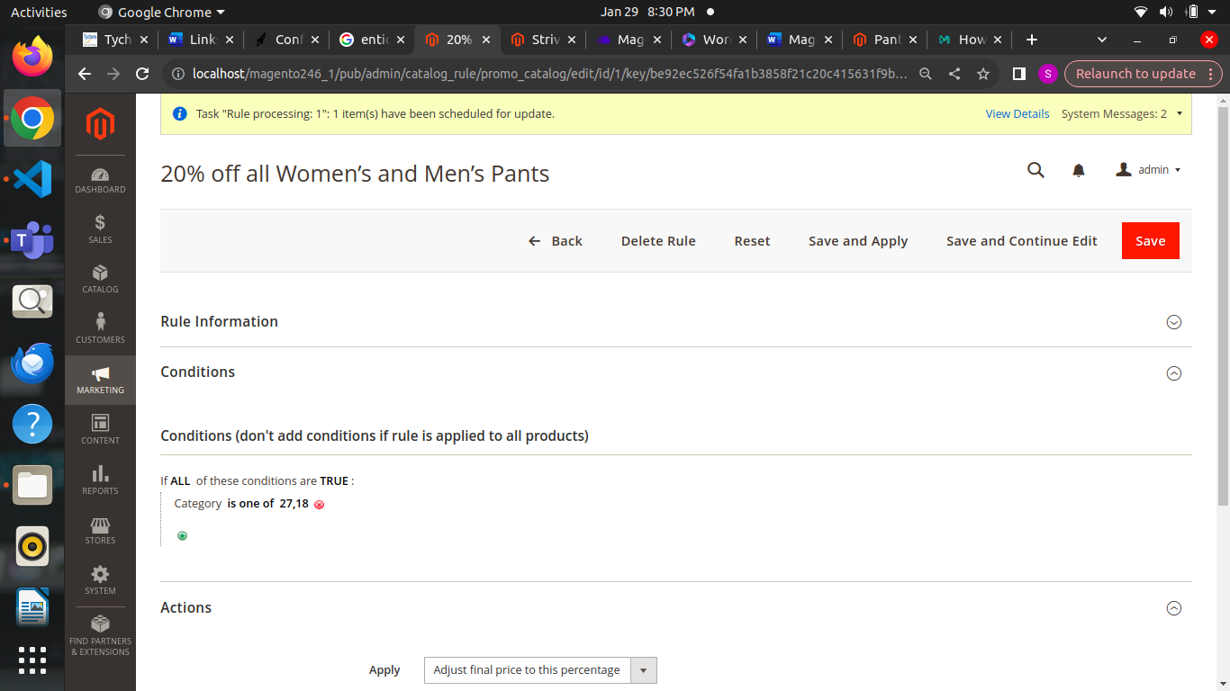

**Uses of catalog price rule:**

* Lay down a special price for a single product, a group of products, or all products on your website.
* Offer a fixed discount from the original price or apply percentage-based discounts on products purchased.
* We can Schedule the start and end dates of the rule so that it automatically expires after a set time.

#### **Applying Conditions to Catalog Price Rules**

* Apply condition is mainly motivates customers to take desired actions.
* Once We set, conditional rules ensure that customers can only get discounts once they meet the criteria.

#### **Catalog Price Rule Actions:**

* **Apply as a percentage of the original**: Creating a percentage-based discount. For example, a 25% discount on the original price.

For Example : Take cronus pant price $48 for this product we are applying catalog price actions Apply as a percentage of the original I am given 20%

=0.2*48 =9.6

=48-9.60

=$38.40

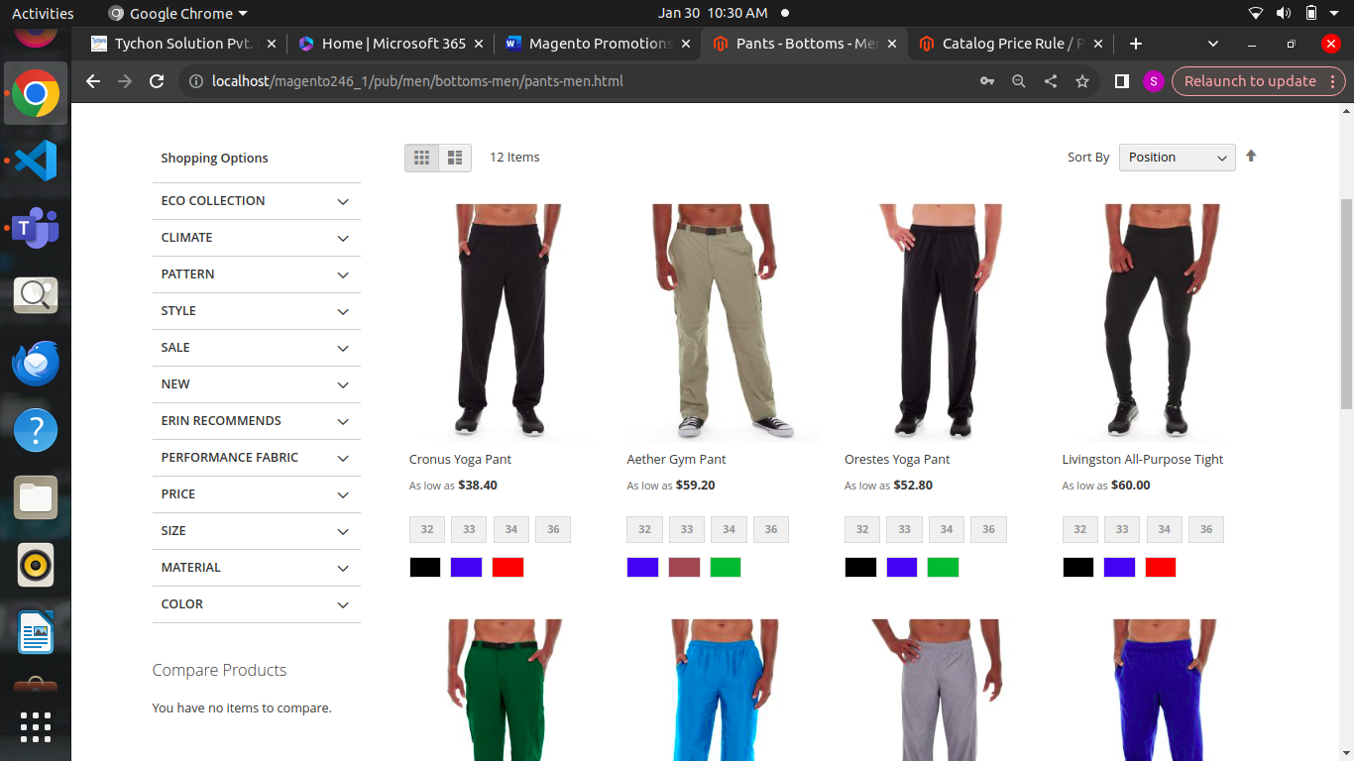

Hence the $38.40 value is applied to the product

* **Apply fixed discount**: Creating fixed discount on the original price. For example, you can set a flat $30 discount on all items in the store that cost above $400

For Example: Take cronus pant price $48 for this product apply as fixed amount hence the given value is 30

=48-30

=18

$18 value is applied to the product

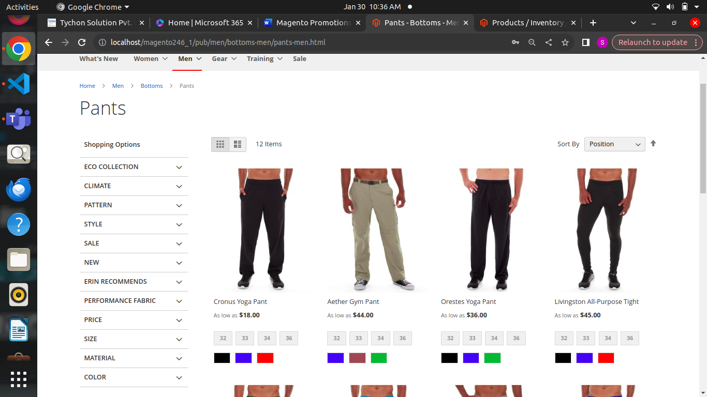

* **Adjust final price to X percentage:** This action allows setting the final price of products to a percentage of their original price. For example, if your store sells a bag originally priced at $800 and sets the discount amount 20%, the product’s price will be adjusted to $640.(The updated price is the percentage of the original price.)

For Example: Take cronus pant price $48 for this product apply as final price to some percentage hence the given value is 35%

=0.35*48

=$16.80

This $16.80 value is applied to the product 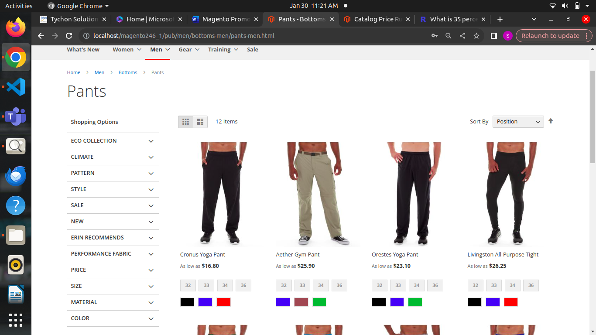

* **Adjust final price to discount value:** This action allows setting the final price of products to a fixed amount (The updated price is a fixed number.)

For Example : Take cronus pant price $48 for this product apply as final price to discount value and given value is 25

Hence it will fix the given value as product price value

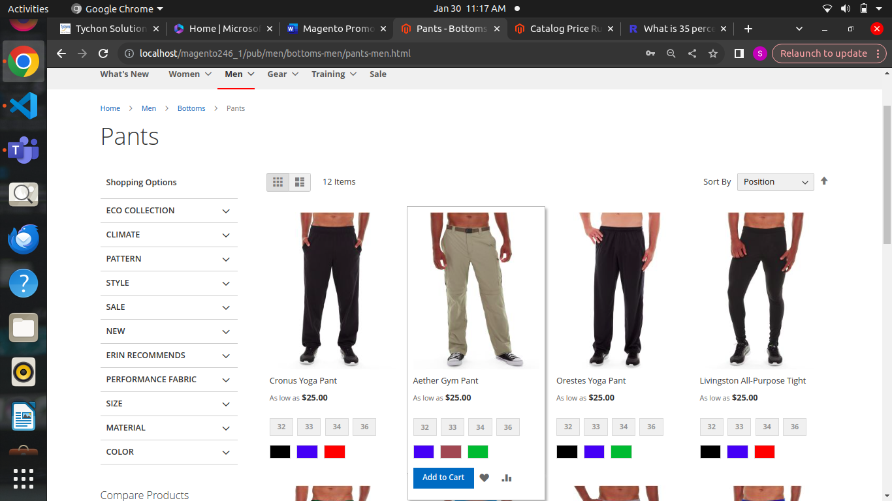

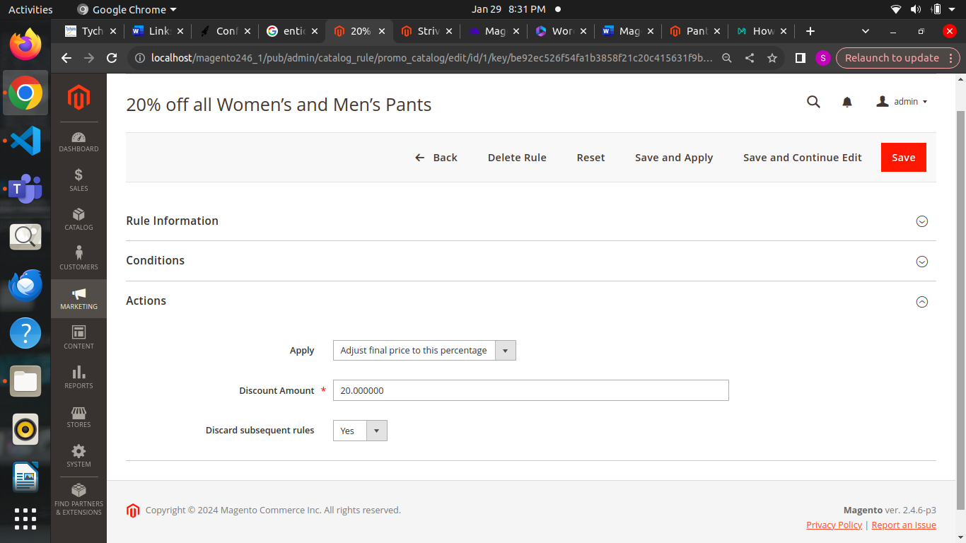

### **Cart Price Rule:**

* Cart Price Rule is a promotion module in Magento 2
* It allows you to set discounts and promotions based on the contents of a customer's shopping cart
* Customers must apply a valid coupon code to their shopping cart to avail of the promotional offer.
* Once Coupon applied, the discounted price should appear under the shopping cart total.

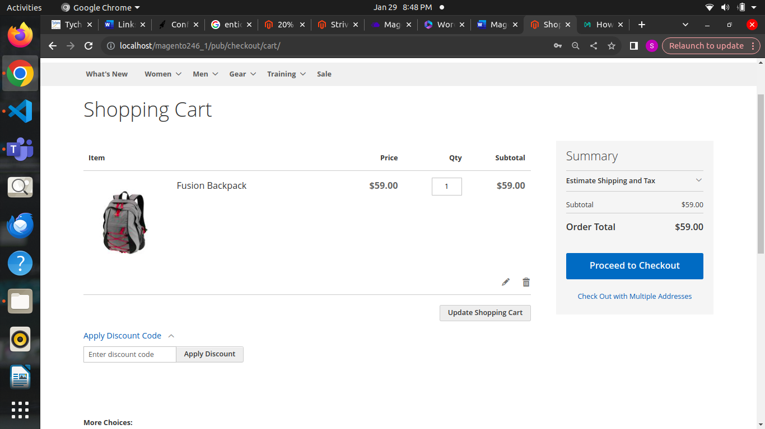

* In the below apply discount code box we need to apply coupon on that box

**To set new cart price rule:**

1.Access the admin panel of Magento.

2.Navigate to the Marketing section. Expand the **cart price rules** tab.

3.Select thepromotions tab and click the Add New Rule button.

4.You can set conditions for your promotion rules (like specific products or customer groups).

5.Choose the actions for your promotion, like discount percentage or fixed price. You can also add additional options like free shipping or gift cards.

**6.Save** your settings and **test** your promotion to ensure it is working correctly.

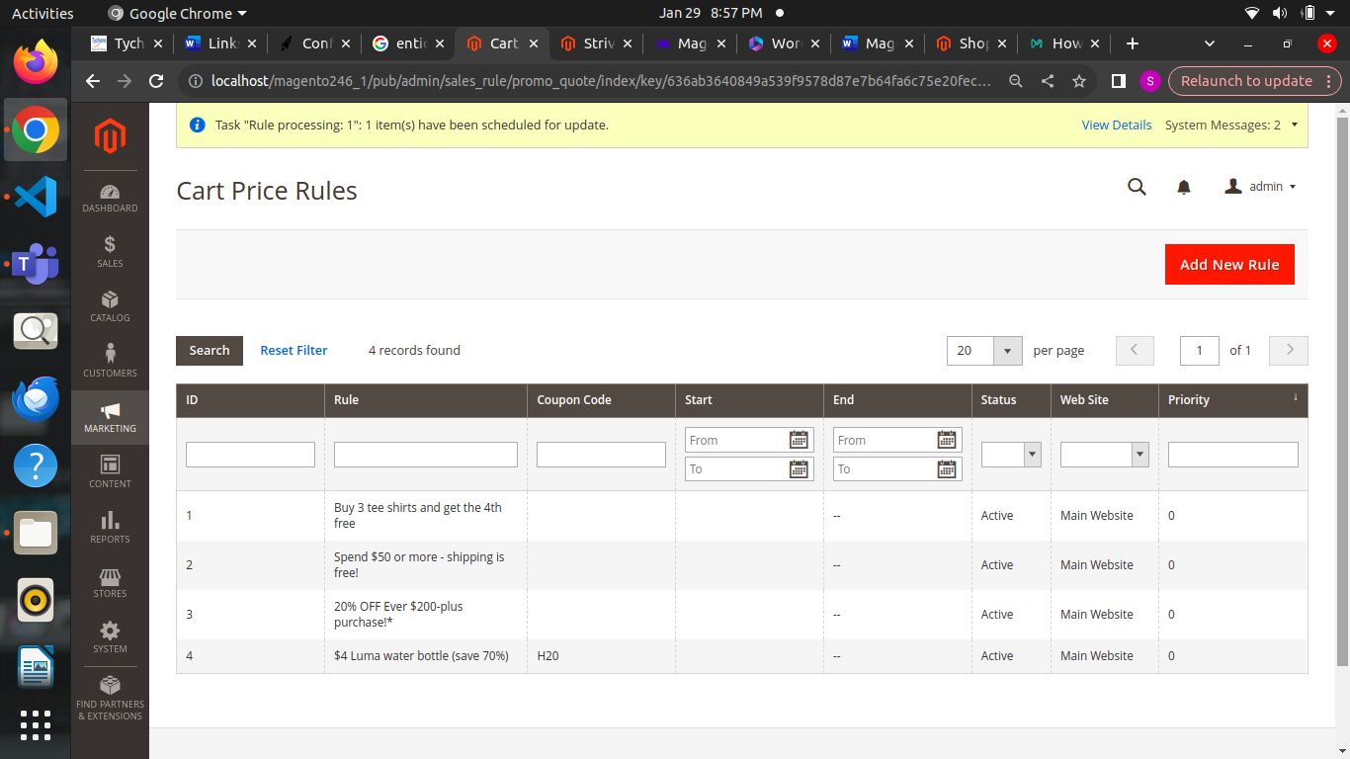

* In the General Information section, set Name for the rule and write some descriptions if needed.
* Enable the rule when Status is **Active**.
* Assign the rule to the Website and Customer Group.

**This promotion is not available for guests who belong to NOT LOGGED IN group or customers who do not log in to their accounts when placing an order.**

* Enable the rule along with the coupon by selecting Specific Coupon option on the Coupon field.
* Insert the Coupon Code that is entered in the checkout process to get the discount. Enable to mark the Use Auto Generation checkbox to publish the [multiple coupon codes](https://www.mageplaza.com/magento-2-multiple-coupons/) after saving the rule.
* Limit the times of using the coupon in the **Uses per Coupon** and **User per Customer**. Leave them empty if there is no limitation.
  + - Uses per Coupon sets the number of times the coupon code is used.
    - Uses per Customers sets the number of times the coupon code is used by the same customers.

**Uses of cart price rule:**

* Upsell seasonal products like winter wear through discounted offers like end-of-season sales.
* Promote slow-moving products from your inventory.
* Suggest related products to boost the average order value (AOV).

#### **Applying Conditions to Cart Price Rules**

* **Minimum order amount:** Customers can only avail of the discount if they buy products with a set amount. For example, $80 off on all purchases above $400. The discount only applies when the total exceeds a certain amount. So, it helps increase sales and encourage customers to spend more on online purchase.
* **Specific products in the cart:** The condition is especially beneficial for upselling slow-selling items. You can provide flat discounts on items that sell lower than others.

#### **Cart Price Rule Actions**

* **Buy X, get Y on a discount:** You can use Magento cart price rules to offer a fixed discount on a pre-selected product to customers who purchase some other product. It can help motivate customers to buy more expensive products from your online store.
* **Avail $Y discount for each $X spent:** The strategy helps offer fixed discounts to customers who spend more over a set threshold. For example, configuring the cart price rules to apply on every dollar customers spend over a purchase of $350.
* **Avail $Y discount for the Cheapest or Most Expensive items in the cart:** It helps upsell the products in your store by creating a sense of urgency.
* **Avail $Y discount for X items in the cart:** It allows you to offer discounts based on the number of products a customer purchases. For example, you can offer a 10% discount if they buy two items or a 20% discount if they buy four items. The offer encourages customers to buy more and increases your sales.

**For Example(with coupon)**

**Percent of product price discount**

* Coupon H20
* In condition we are given a product sku
* Product name:Affirm water bottle => $7
* Discount 70%

=70% of $7

=$4.90

=$7.00-$4.90

=$2.10

* The $2.10 value will be shown in the cart page after applying the coupon

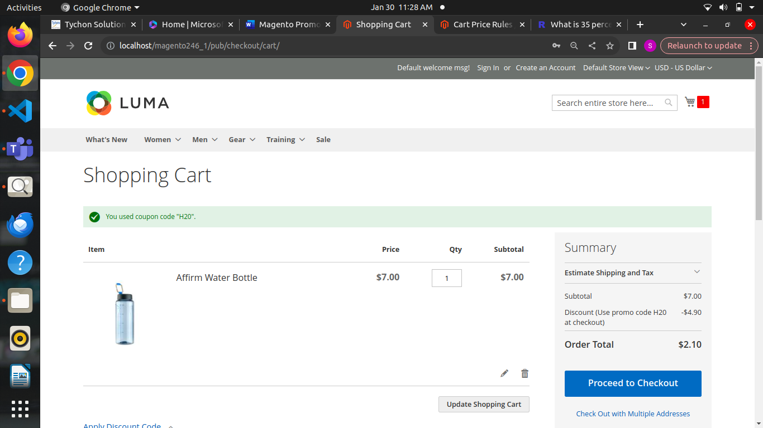

**Fixed amount discount**

* Example given discount 3
* Hence it will get subtract from the original price

=$7-$3 =$4

* Hence the $4 value is get displayed in the cart page after applying coupon

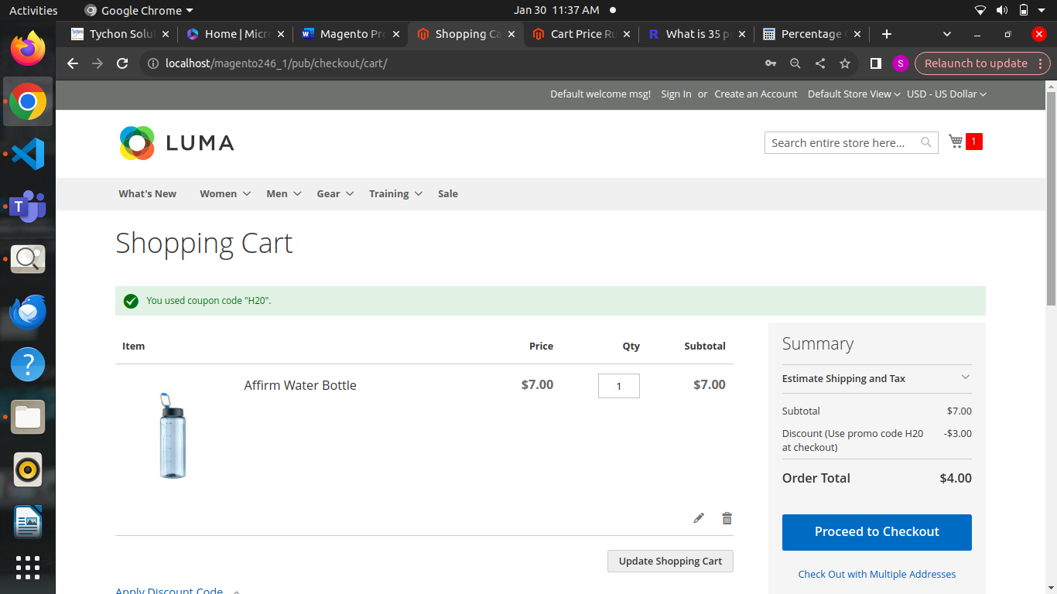

**Fixed amount discount for whole cart**

* For Example we given 5 in the discount value
* It will reduce $5 value from the overall cart product price

Affirm Water bottle => $7

Bag => $34

Total = $41

* In total $41 subtract $5 =>$36
* Hence the final value must be $36 in the cart page when the coupon is applied the $5 value is get reduced

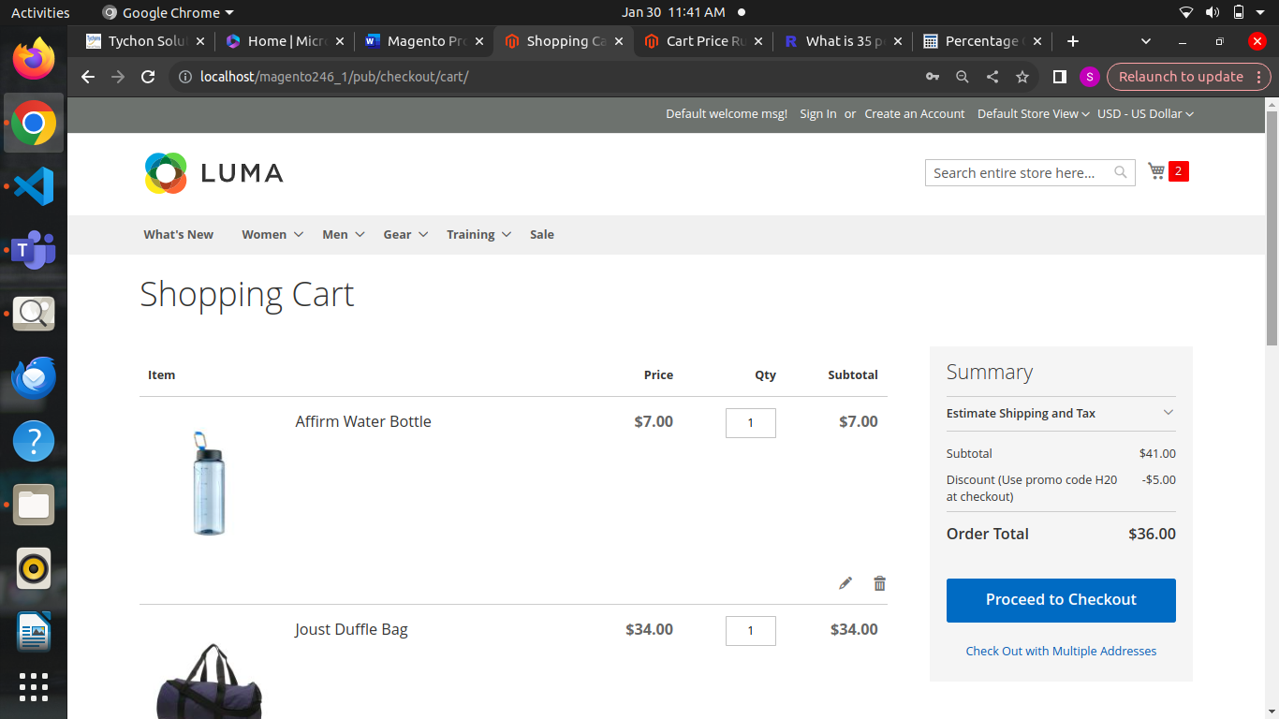

**Buy X get Y free (Discount amount is y)**

* Apply: Buy X get Y free (discount amount is Y)
* Discount amount: 1
* Maximum Quantity Discount is Applied: 0
* Discount Qty Step (Buy X): 7
* Buy 7 get 3 free
* X = The number of items the customer must purchase to get the discount.
* Y = The number of items the customer will receive for free
* M = Maximum number of free items allowed
* X = 7
* Y = 3
* M = 6
* (X+Y) * (M/Y)
* (7+3) * (6/3) = 20
* Discount 20 is reduced from the cart

**For Example (without coupon)**

**Buy X get Y free (Discount amount is y)**

Here same like the above concept apply to all the items giving condition for tees product and the product quantity must be three (3) hence in overall cart value is get reduced $45 amount

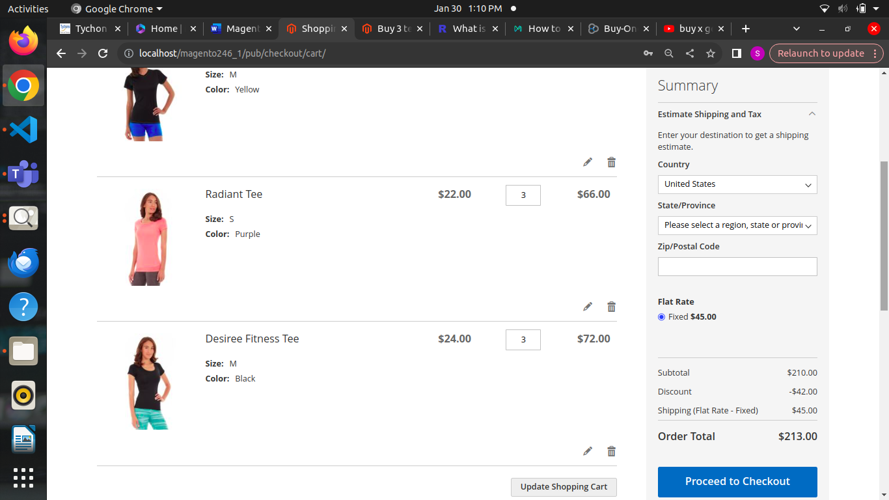

**Percent of Product Price**

Set the product quantity 3 and in overall subtotal the discount is applied and the final value is reduced based on the discount amount

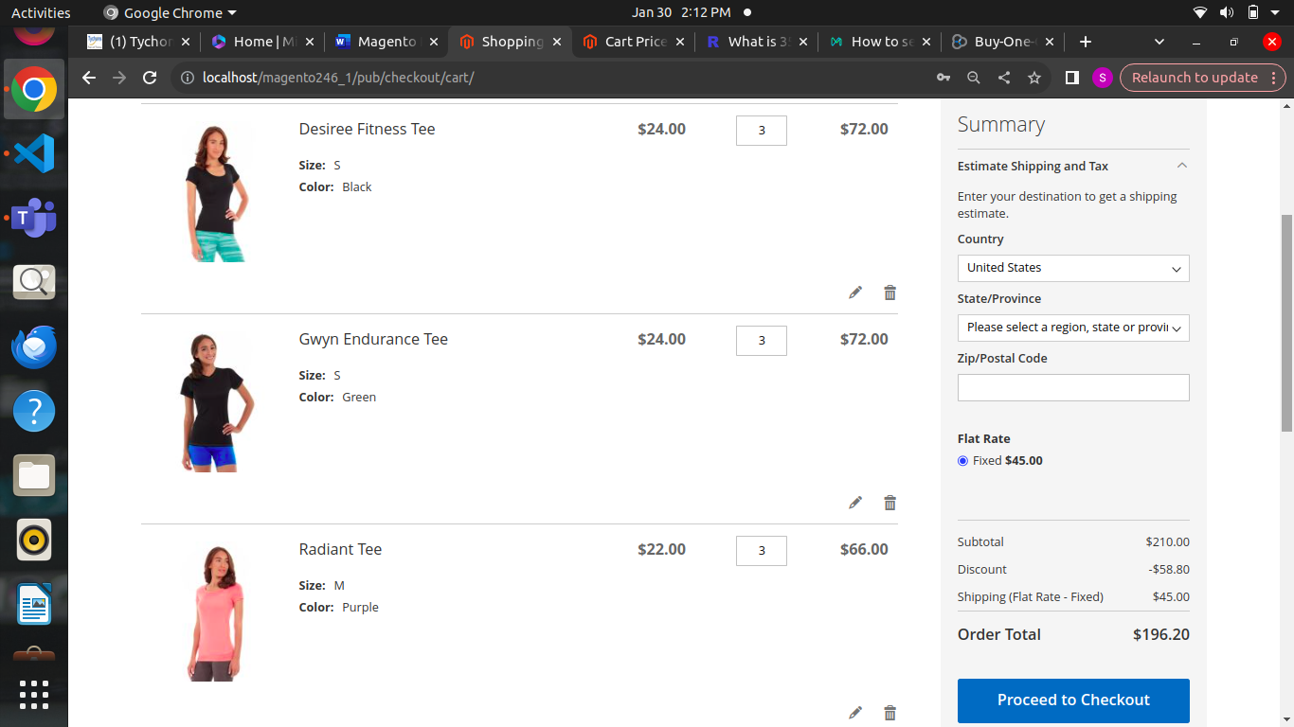

**Fixed Amount discount**

In fixed amount discount is applied to the discount applies to each qualifying item in the cart.

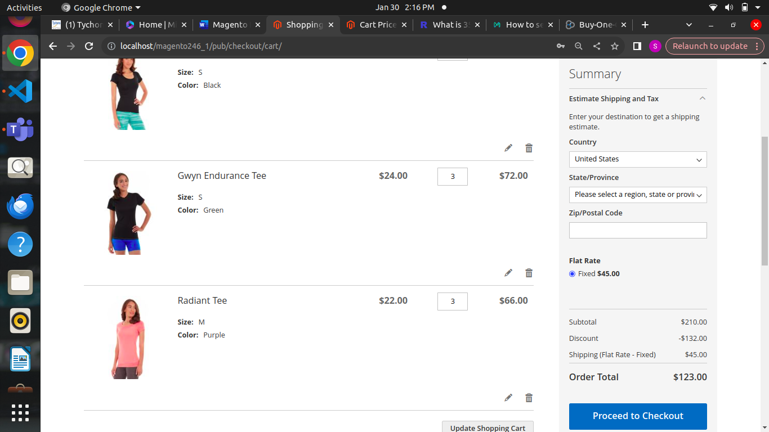

**Fixed Amount discount for whole** **cart :**

Discounts the entire cart by subtracting a percentage from the cart total.

